University of Montenegro
Faculty of Political Sciences
Cordially invites you to
The Workshop and Interactive Discussion
Will the Western Balkans be a part of Euro-Atlantic institutions?
Crisis of the liberal consensus in the Western Balkans
with
Marko SAVKOVIĆ
Program Director, Belgrade Fund for Political Excellence
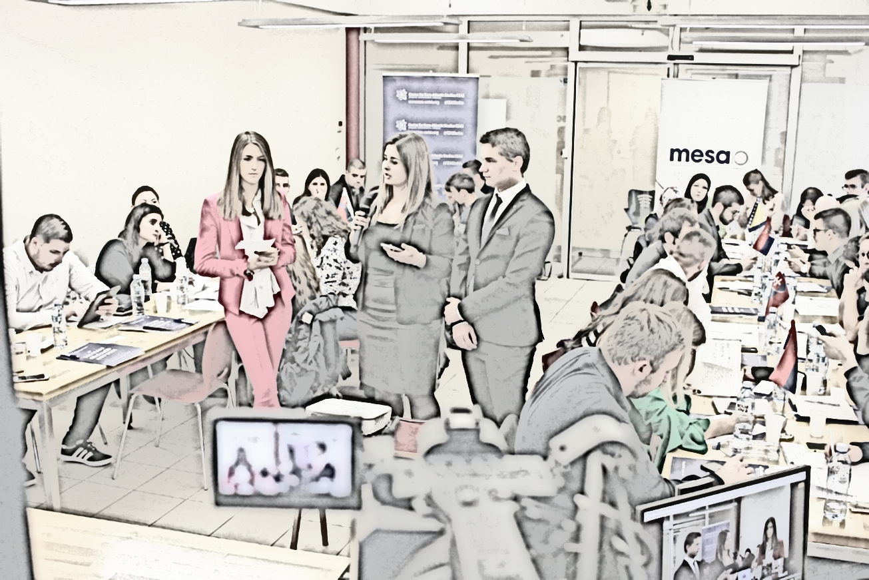
on 11th March 2019, 10:00 a.m., Room XXYY

Broadcast live from Belgrade, Serbia, with the participation of students from: Academy of Economic Studies of Moldova, Chisinau; University of Montenegro, Podgorica; International University of Sarajevo; University of Novi Sad; University of Belgrade; Comenius University, Bratislava; Matej Bel University, Banska Bystrica.

Workshop is open to all students who interested in learning about the world.
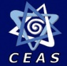
Organized in cooperation with:

